Spring boot 3 with Micrometer, Prometheus and Grafana

- Install Prometheus
Download: https://prometheus.io/download/
prometheus-3.7.3.windows-amd64.zip
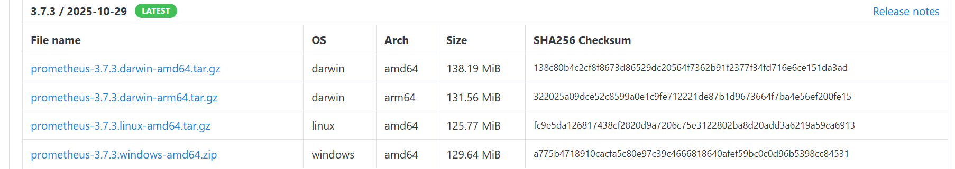

unzip in C-drive and edit prometheus.yml:
global:
scrape_interval: 5s

scrape_configs:
- job_name: 'spring-boot-app'
metrics_path: '/actuator/prometheus'
static_configs:
- targets: ['localhost:8080']

Start:
C:\prometheus-3.6.0-rc.1.windows-amd64\prometheus-3.6.0-rc.1.windows-amd64>prometheus.exe --config.file=prometheus.yml

Open: http://localhost:9090

Query: hikaricp_connections_active{application="$application"}

- Install Grafana
Download windows installer: https://grafana.com/grafana/download


Start Grafana:
- Windows: grafana-server.exe
C:\Program Files\GrafanaLabs\grafana\bin>grafana-server.exe
- Linux: sudo systemctl start grafana-server
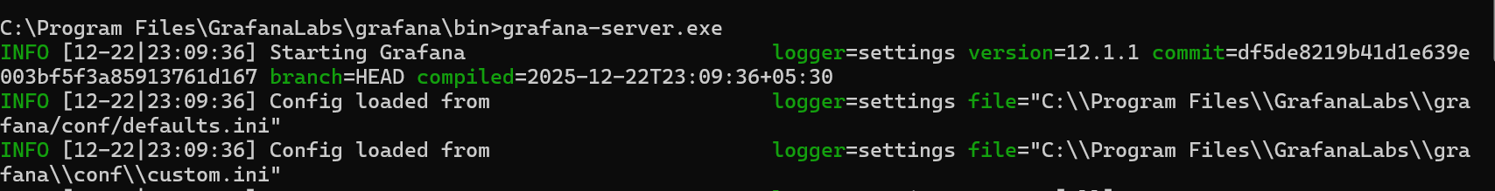

Open Grafana UI:
http://localhost:3000

Login default:
user: admin
pass: admin

Add Prometheus Data Source
Grafana UI → Configuration → Data Sources → Add Prometheus
URL: http://localhost:9090
Save & Test
Import dashboard:
Dashboard -> new -> import (either use ID or json)
- For JVM: ID = 4701
- Spring Boot2.x Micrometer1 dashboard: ID = 11378
- Spring Boot3.x Micrometer2 dashboard: use json

{
"__inputs": [],
"__elements": {},
"__requires": [
{
"id": "prometheus",
"name": "Prometheus",
"type": "datasource",
"version": "2.0.0"
},
{
"id": "grafana",
"name": "Grafana",
"type": "panel",
"version": "10.0.0"
}
],
"title": "Spring Boot 3 Micrometer (Prometheus)",
"uid": "springboot3-metrics",
"timezone": "browser",
"schemaVersion": 38,
"version": 1,
"refresh": "10s",
"panels": [
{
"type": "stat",
"title": "Uptime",
"datasource": "${prometheus}",
"targets": [
{
"expr": "process_uptime_seconds",
"legendFormat": "uptime",
"refId": "A"
}
],
"gridPos": {
"x": 0,
"y": 0,
"w": 4,
"h": 4
}
},
{
"type": "graph",
"title": "HTTP Request Duration (avg)",
"datasource": "${prometheus}",
"targets": [
{
"expr": "rate(http_server_requests_seconds_sum[1m]) / rate(http_server_requests_seconds_count[1m])",
"legendFormat": "{{method}} {{uri}}",
"refId": "A"
}
],
"gridPos": {
"x": 4,
"y": 0,
"w": 12,
"h": 8
}
},
{
"type": "graph",
"title": "HTTP Requests Rate",
"datasource": "${prometheus}",
"targets": [
{
"expr": "rate(http_server_requests_seconds_count[1m])",
"legendFormat": "{{method}} {{uri}} {{status}}",
"refId": "A"
}
],
"gridPos": {
"x": 0,
"y": 8,
"w": 12,
"h": 8
}
},
{
"type": "graph",
"title": "JVM Heap Memory Usage",
"targets": [
{
"expr": "jvm_memory_usage_bytes{area=\"heap\"}",
"legendFormat": "{{id}}",
"refId": "A"
}
],
"gridPos": {
"x": 12,
"y": 8,
"w": 12,
"h": 8
}
},
{
"type": "graph",
"title": "JVM GC Pause Duration",
"targets": [
{
"expr": "rate(jvm_gc_pause_duration_seconds_sum[1m])",
"legendFormat": "{{action}} {{cause}}",
"refId": "A"
}
],
"gridPos": {
"x": 0,
"y": 16,
"w": 12,
"h": 8
}
},
{
"type": "graph",
"title": "CPU Usage",
"targets": [
{
"expr": "rate(process_cpu_seconds[1m])",
"legendFormat": "CPU usage",
"refId": "A"
}
],
"gridPos": {
"x": 12,
"y": 16,
"w": 12,
"h": 8
}
},
{
"type": "graph",
"title": "HikariCP - Active Connections",
"targets": [
{
"expr": "hikaricp_connections_active",
"legendFormat": "active",
"refId": "A"
}
],
"gridPos": {
"x": 0,
"y": 24,
"w": 12,
"h": 8
}
}
]
}

- Maven dependency

<dependency>
<groupId>io.micrometer</groupId>
<artifactId>micrometer-registry-prometheus</artifactId>
</dependency>

<dependency>
<groupId>org.springframework.boot</groupId>
<artifactId>spring-boot-starter-actuator</artifactId>
</dependency>

- Application.properties

management.endpoints.web.exposure.include=*
management.endpoint.prometheus.enabled=true
management.metrics.export.prometheus.enabled=true

# optional: enable JVM metrics
management.metrics.enable.jvm=true
management.metrics.enable.process=true
management.metrics.enable.system=true

- Check actuator

Run application and check:
http://localhost:8080/actuator/prometheus

You should see Prometheus formatted metrics like:
jvm_memory_used_bytes{area="heap",id="G1 Eden Space",} 12345678
jvm_gc_pause_seconds_count 45
process_cpu_usage 0.42

- Grafana dashboard:

This dashboard will show:
- Heap memory used vs committed
- GC pause time
- Thread count
- CPU process usage
- Class loading
- OOM alerts possible

Detecting OOM
Key metrics to watch:
Metric | Description
jvm_memory_used_bytes{area="heap"} | Heap consumption
jvm_memory_max_bytes{area="heap"} | Heap limit
jvm_gc_pause_seconds_sum | GC stall indicator
process_cpu_usage | CPU load spike
jvm_threads_live_threads | Thread leak
jvm_buffer_memory_used_bytes | Off-heap buffer leaks

